**LEWIS UNIVERSITY**

**Course: OBJECTED ORIENTED DEVELOPMENT**

**Professor: Fadi Wedyan**

**Assignment-1**

**Empirical Study: Effect of Class size on software maintainability**

**Group members:**

**1: Malreddy Pavani Reddy (L30084297)**

**2. Renukunta Ushaswini (L30066977)**

**Github link: https://github.com/PavaniMalreddy/GroupPoject1**

Section 1:

GQM approach: A widely-used research approach in the industry and academia. Originally designed for a set of NASA projects at the Goddard Space Flight Center. Based upon the assumption that a study to measure in a purposeful way it must first specify the goals, then it must trace those goals to the data that are intended to define those goals.

Goals identify what we want to accomplish. Questions, when answered, tell us whether we are meeting the goals or help us understand how to interpret them; Metrics identify the measurements that are needed to answer the questions and quantify the goal.

From the Assignment1 perspective, the goal is to conduct an empirical study: Effect of class size on software maintainability.

Question: what is the effect of the class size on software maintainability?

Metrics:

Introduced by Chidamber and Kemerer, best know as (C&K) metrics suite. Designed to:

Measure aspects of OO software

Measure the complexity of the design

Improve software development.

**CBO (Coupling Between Objects)**

**RFC (Response for Class)**

**Lines of Code**

Section 2:

Subject Programs

|  |  |
| --- | --- |
| **SNo** | **Project Name** |
| 1 | Hospital Management |
| 2 | Computer Store |
| 3 | Multi Threading master |
| 4 | Design patterns |
| 5 | Huston |

Section3:

CK metrics, also known as Chidamber and Kemerer metrics, are a set of software metrics used to assess the complexity and maintainability of object-oriented software systems. They were introduced by Shyam R. Chidamber and Chris F. Kemerer in their paper "A Metrics Suite for Object-Oriented Design" in 1994.

The CK metrics aim to measure various aspects of software quality and provide insights into the design and maintainability of object-oriented systems. These metrics are computed by analyzing the structure and relationships among the classes in the system.

Here are some commonly used CK metrics:

* Weighted Methods per Class (WMC): It measures the complexity of a class by counting the total number of methods it contains. A higher WMC value indicates a more complex class.
* Depth of Inheritance Tree (DIT): It measures the level of class inheritance in the system. It counts the number of levels from a class to the root of the inheritance hierarchy. A higher DIT value indicates a deeper and potentially more complex inheritance structure.
* Number of Children (NOC): It measures the number of immediate subclasses of a class. A higher NOC value indicates a higher level of specialization and potentially greater complexity.
* Coupling between Objects (CBO): It measures the number of other classes that a class is directly coupled to. It provides an indication of the interdependencies between classes. A higher CBO value indicates a higher degree of coupling, which can increase the complexity and difficulty of maintenance.
* Lack of Cohesion in Methods (LCOM): It measures the cohesion of methods within a class. It indicates how closely related the methods are in terms of the instance variables they access. A higher LCOM value suggests lower cohesion, which may indicate poor design and potential maintenance difficulties.

Section4:

|  |  |  |  |
| --- | --- | --- | --- |
| Project Number | CBO | RFC | LOC |
| 1 | 2.12 | 1.79 | 14.16 |
| 2 | 1.74 | 1.97 | 10.55 |
| 3 | 6.68 | 8.96 | 55.54 |
| 4 | 2.15 | 3.92 | 16.07 |
| 5 | 3.30 | 5.53 | 33.84 |

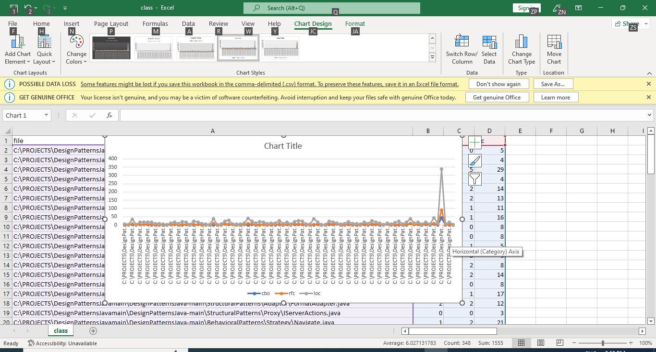

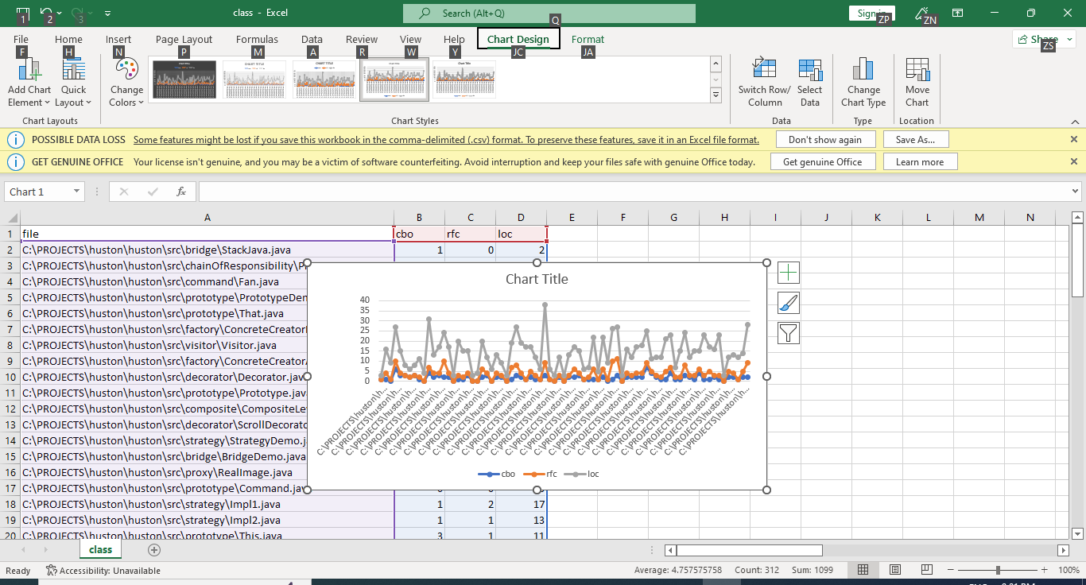

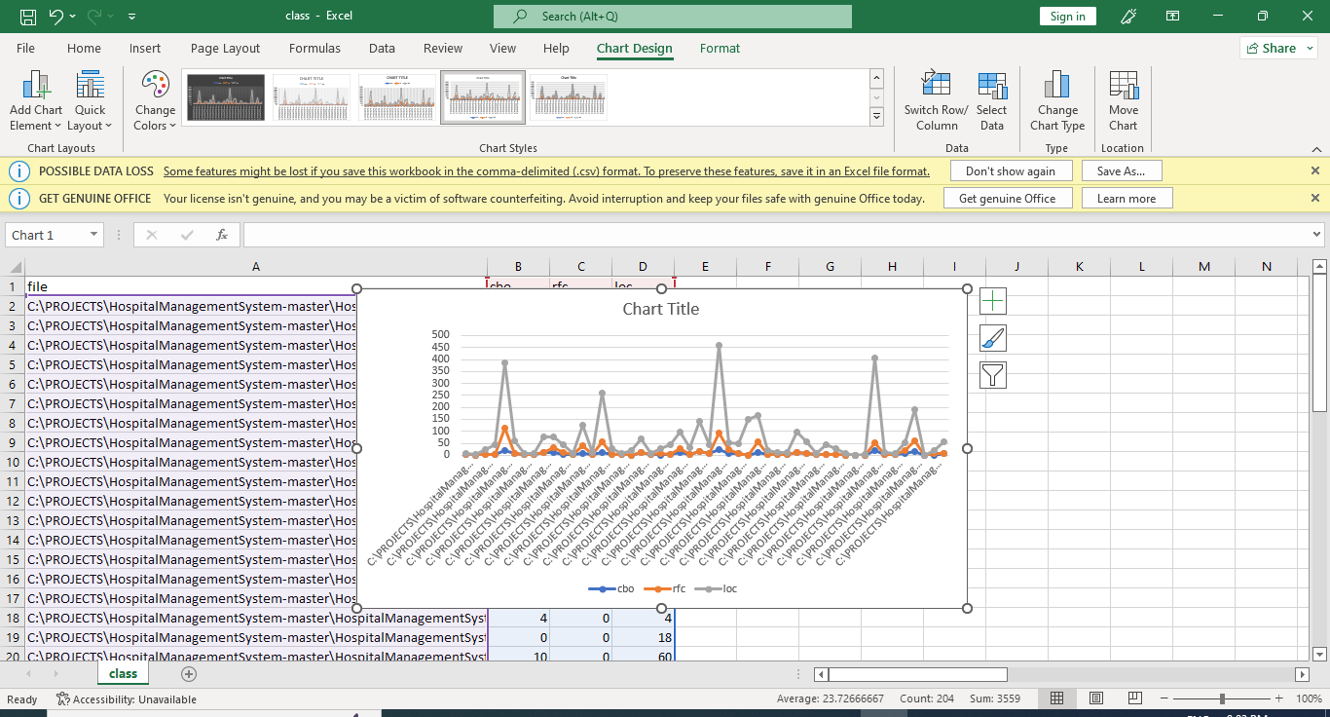

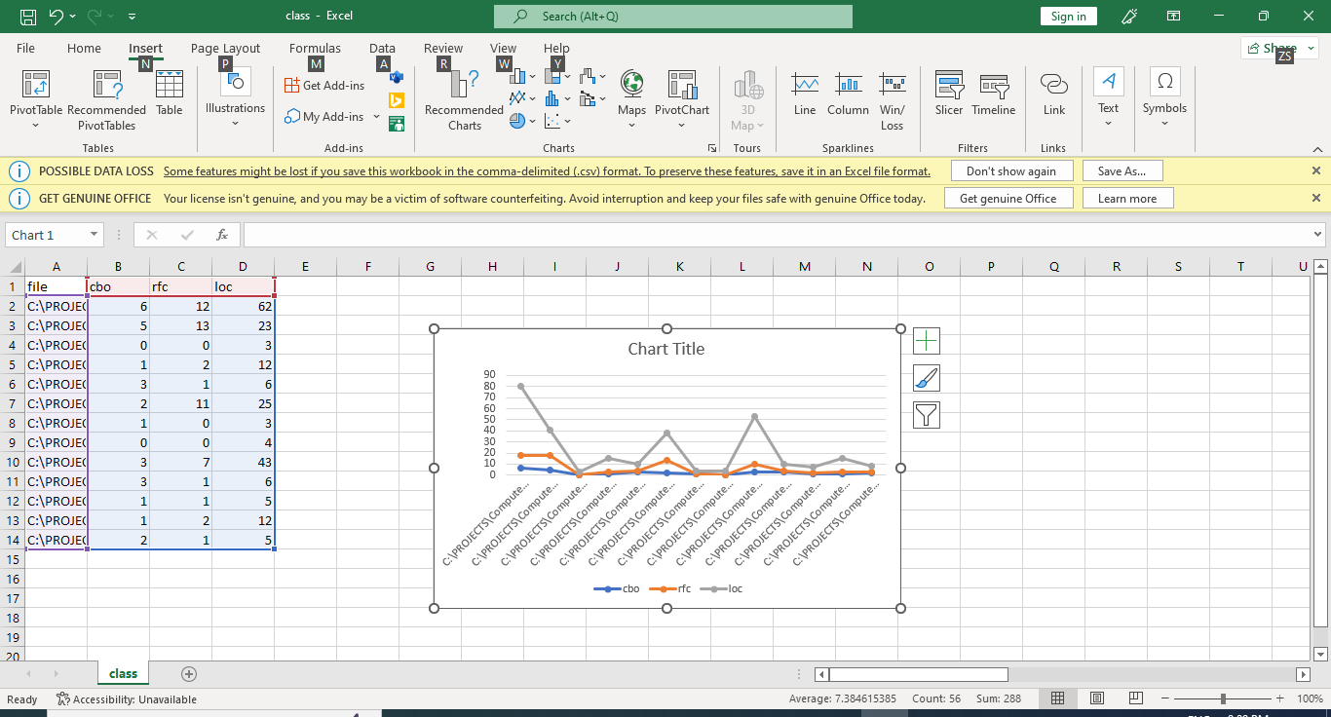



Conclusions:

Low value of CBO: Improve modularity which promote encapsulation, improves reusability, maintainability, and testability. If RFC is high: Increased complexity- testing and maintaining the class is harder.

In this assignment1, I am considering the three metrics: CBO, RFC, LOC. From the tables and graphs I can say that the projects I selected have the low CBO, RFC, LOC metric values. From this I can say that there is an effect of class size on maintainability. Excessively large LOC count can sometimes indicate potential maintainability issues. And these low metric values lead to high software project maintainability.

References:

<https://www.geeksforgeeks.org/goal-question-metric-approach-in-software-quality/>

<https://www.aivosto.com/project/help/pm-oo-ck.html>

[www.github.com](http://www.github.com)